Calculus AB The Derivative of the Inverse of a Function Name
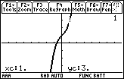
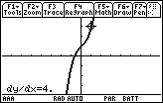
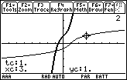
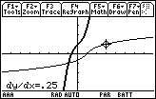
Sect 5.3 Date

Example: f(x) = x³ + x + 1 passes through the point (1,3). See figure 1.
f ′(x) = 3x² + 1, which is always positive. That implies that f(x) is strictly increasing. That implies that f(x) has an inverse, although it would be difficult/impossible to find an equation for f ^{–1}(x).

Using the calculator to graph f ^{–1}(x):
Method 1: Use F6 Draw DrawInv. The calculator will return you to the Home screen, and you type in DrawInv y1(x). This will show the shape of the inverse graph, but you will not be able to trace along the inverse.

Method 2: Use Parametric Mode
xt1 = t
yt1 = t³ + t +1
xt2 = t³ + t +1 or xt2 = yt1 This method interchanges x and y.
yt2 = t yt2 = xt1

Notice f ′(1) = 4. The slope of the tangent line at (1,3) equals 4. See figure 2 above.
This will mean that f ^{–1} ′(3) = ¼. The slope of f-inverse as it passes through (3,1) is the reciprocal of f ′(1).

- Exercises
For each function below, find f ^{–1}(x).
Graph f(x) and draw the tangent line at (0,f(0)). On the same axes, graph f ^{–1}(x) and draw the tangent at (f(0),0). Compare the slopes of the two tangent lines.

- f(x) = 4x – 3
- f(x) = √ x + 1
- f(x) = ³√ x + 8
- f(x) = 8x³
- f(x) = 2x – 3
x + 2

- Find f ^{–1} ′(d) for the given values of f(x) and d.

6) f(x) = √ 3x + 1 d = 1

7) f(x) = x² – 16, x ≥ 0 d = 9

8) f(x) = √ 4 – x d = 3

9) f(x) = x³ + 5 d = -3

10) f(x) = 3x⁵ + 2x³ d = 5

11) f(x) = sin x, -π/2 < x < π/2 d = ½

12) f(x) = 2x² + 8x + 7, x ≤ -2 d = 1

