Arithmetic Series  Geometric Series  Probability and Statistics  Basic Counting Principle with m,n, and l different items =  Transformations (a,b,h,k >0) | Fractions  Conjugate  of a + b is ____________  (a-b)(a+b)=  Horizontal Asymptote Rules:  1.  2.  3.  Vertical Asymptote Rules:  Imaginary Numbers: | Arithmetic Operations  Parent Functions  Graph  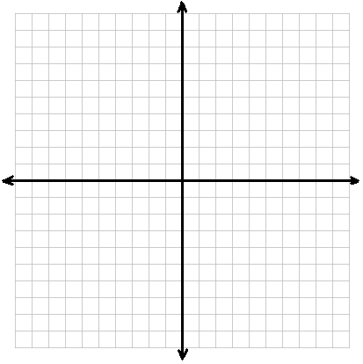
Exponents and Radicals  Interest/Half-Life  Compound Interest:  Continuously Compounded:  Exponential Growth/Decay: | Logarithm Rules  Change from log to exponential  Change from exponential to log  More log rules  Change of base formula  Intercepts  To find the x-intercept of any function:  To find the y-intercept of any function: | Conics (standard forms)  Circle:  Parabola  Vertical:  Horizontal:  Ellipse  Vertical:  Horizontal:  Hyperbola  Vertical:  Horizontal:  Complete the Square:  Factoring  Difference of Squares  Difference of Cubes  Sum of Cubes  Perfect Square Trinomial  Grouping

