Houston Area Calculus Teachers Nov. 5, 2016 Building New Functions

AB/BC #1 2016

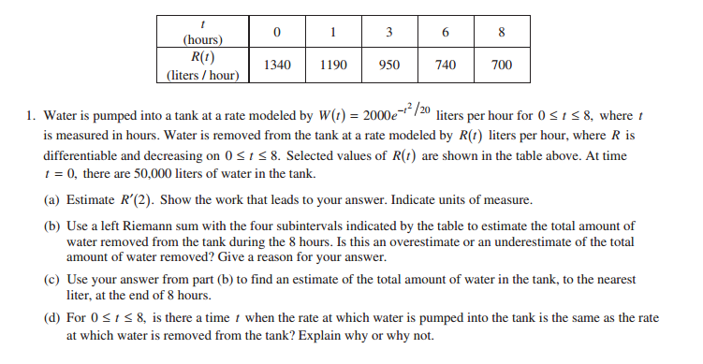

2016 AB/BC 1d was scored such that a student was rewarded when they built a new function from the given functions in the problem. My first reaction was to consider what if my students did not build a new function? Were they treated fairly? Could they demonstrate as much knowledge without building a new function and still earn the points? During a casual conversation, a friend, Tom argued that the scoring of a student isn't the important point. He claims that we want to encourage students to begin to build their own functions in order to reason efficiently.

“Students were averse to constructing a new function, W(t) – R(t), to which IVT could be applied. Nearly all students working on this part chose to view W and R as competing functions with W starting above and finishing below R on the interval [0, 8]. With this approach a complete explanation needed to apply the IVT twice, to each of W or R (or appeal to the continuity of both W and R). Many students noting the range of W contains the range of R on the interval failed to note the crucial assumption of continuity for both functions.” Student Performance Q & A.

Intermediate Value Theorem

Let f be a functions defined on [a, b] and let W be a number between f(a) and f(b). If f is continuous on [a, b], then there is at least one number c between a and b such that f(c) = W.

Reflect, where do we build new functions in mathematics curriculum? Or might I say where have we built new functions?

* Classic Maximum and Minimum Problems

1990 BC 3

Let  for  and 

1. The line tangent to the graph of *f* at the point  intercepts the *x*-axis at *x* = 4. What is the value of *k*?
2. An isosceles triangle whose base is the interval from  to  has its vertex on the graph of *f*. For what value of *c* does the triangle have maximum area? Justify your answer.
3. A manufacturer wants to design an open box having a square base and a surface area of 108 square inches. What dimensions will produce a box with maximum volume?
4. A tank with a rectangular base and rectangular sides is open at the top. It is to be constructed so that its width is 4 meters and its volume is 36 cubic meters. If building the tank costs $10/sq. m. for the base and $5/sq. m. for the sides, what is the cost of the least expensive tank, and what are its dimensions?
5. A cylindrical metal container, open at the top, is to have a capacity of  cu. in. The cost of material used for the bottom of the container is $0.15/sq. in., and the cost of the material used for the curved part is $0.05/sq. in. Find the dimensions that will minimize the cost of the material, and find the minimum cost.

* Profit is equal to Revenue minus Cost

Summary of Business Terms and Formulas

*x* is the number of units produced (or sold

*p* is the price per unit

*R* is the revenue from selling *x* units R = x p

C is the cost of production *x* units

 is the average cost per unit 

P is the total Profit from selling *x* units P = R – C

Describe

When is R = C.   

The cost per unit for the production of a radio is $60. The manufacturer charges $90 per unit for orders of 100 or less. To encourage large orders the manufacturer reduces the charge by $0.15 per radio for each unit ordered in excess of 100 (for example, there would be a charge of $87 per radio for an order size of 120)

1. Analytically complete the table.

|  |  |  |
| --- | --- | --- |
| x | Price | Profit |
| 102 |  |  |
| 104 |  |  |
| 106 |  |  |
| 108 |  |  |
| 110 |  |  |
| X |  |  |

1. Write the profit P as a function of x.
2. Use calculus to find the critical number of the function in part (b) and find the required order size.
3. Use a graph to graph the function in part (b) and confirm the maximum profit from the graph.

A real estate office handles 50 apartment units. When the rent is $720 per month, all units are occupied. However, on the average, for each $40 increase in rent, one unit becomes vacant. Each occupied unit requires an average of $48 per month for service and repairs. What rent should be charged to obtain the maximum profit?

1982 AB 6 and BC 3

A tank with a rectangular base and rectangular sides is to be open at the top. It is to be constructed so that its width is 4 meters and its volume is 36 cubic meters. If building the tank costs $10 per square meters for the base and $5 per square meter for the sides, what is the cost of the least expensive tank?

* In/Out problems from past AP exams

