Saturday 1/19/2018 Houston Area Calculus Teachers Scott Pass

Reflecting on 2018 AB/BC 3

AB/BC 3 2018

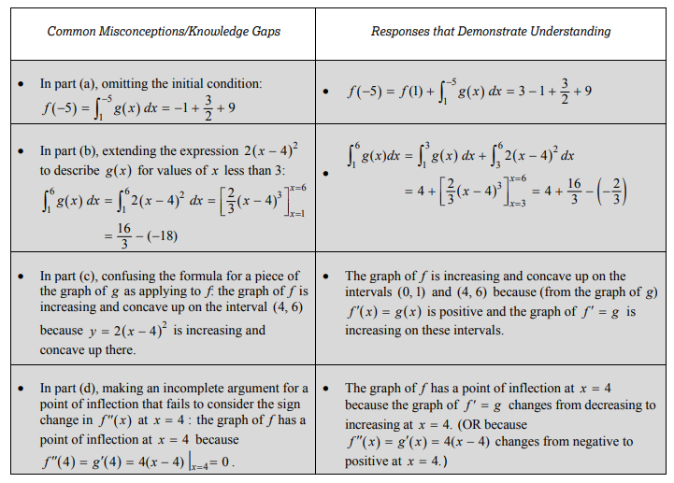

* 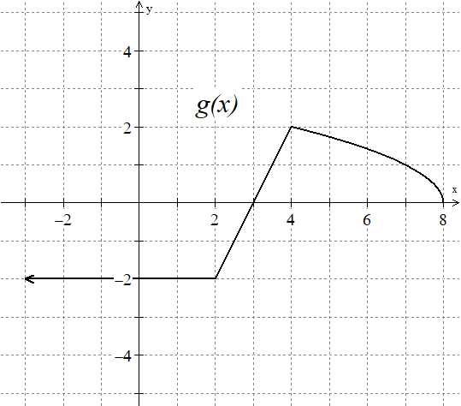Working with graphical and analytic mixed.

1. The graph of a continuous function g, the derivative of f, is a piecewise linear for , and  for 
2. If , what is the value of 
3. Evaluate .
4. Determine when f is decreasing and concave up. Explain.
5. 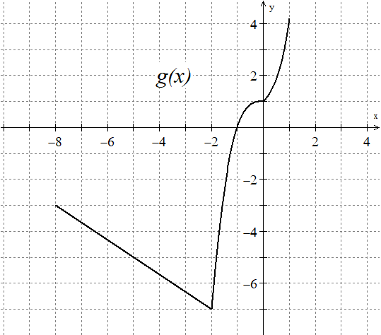The graph of a continuous function g, the derivative of f, is linear for , and  for  and for .
6. 
7. Evaluate
8. Is there a relative extrema on f(x). If so, Identify and classify the relative extrema. If not, explain why.

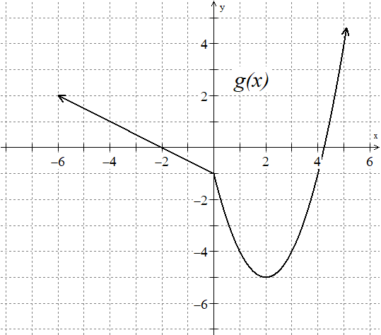

1. The graph of a continuous function g, the derivative of f, is a piecewise linear for , and  for 
2. On what intervals is f increasing?
3. At what x-values does f have a point of inflection?
4. Evaluate 

AB/BC 4 2018

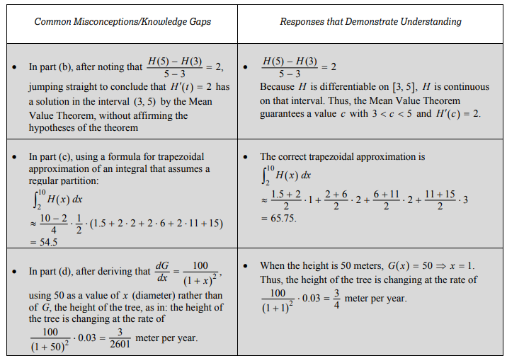

Consider more contextual related rates problems (2007 AB/BC 4)

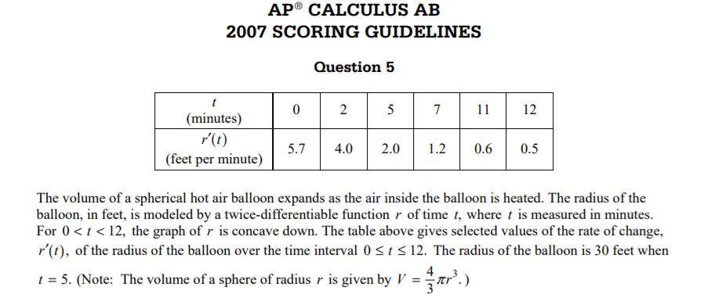

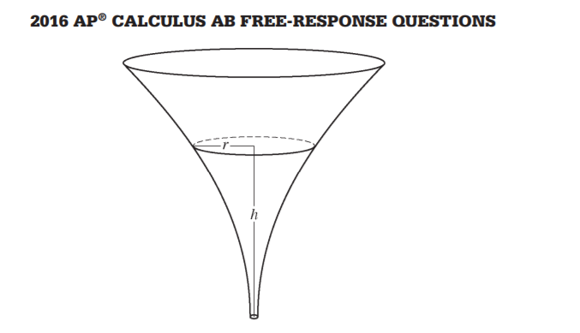



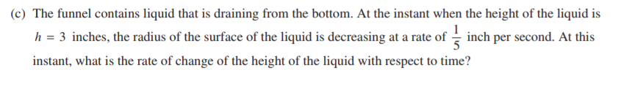

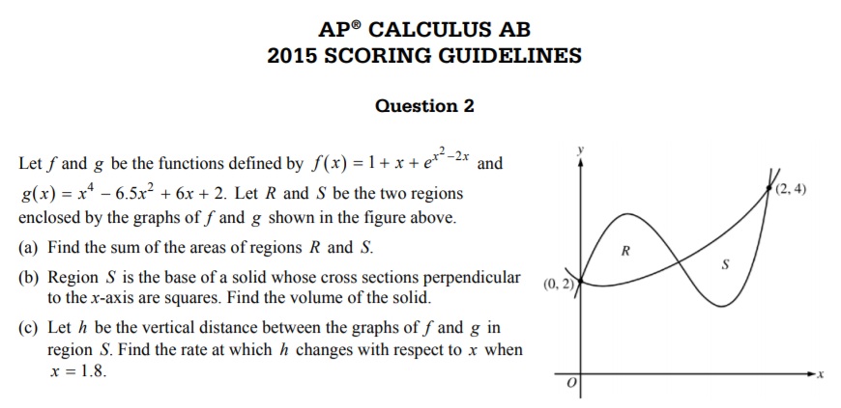

We can solve differential equations three ways: Numerically with Euler’s method, Graphically with slope fields and analytically.

* Thinking about differential equations

1. Show that is a solution to the equation  is a solution to the equation .
2. Consider the differential equation given by . Could a solution to the differential equation have the graph shown? Explain.



1. Consider the possible solutions for the differential equation represented by the slope field. Since we do not know the differential equation describing the slope field we investigate this graphically.
2. Sketch the particular solution passing through (4, 1)
3. Sketch the particular solution passing through (2, -1)
4. Notice that all the slopes in Quadrant I are negative in fact the slope at the point (1, 1) is –0.2, try and write a differential equation that is plausible for this slope field.
5. The general solution to the differential equation modeling how a person learns is . For which initial condition  or  would we expect could best represent the way a person learns.
6. Four pairs of species are given, with descriptions of how they interact.

I. Bees/flowers: each needs the other to survive

II. Owls/trees: owls need trees but trees are indifferent

III. Elk/buffalo: in competition and would do fine alone

IV. Fox/hare: fox eats the hare and needs it to survive

Match each system of differential equations with a species pair, and indicate the species is x and which is y.



1.  (B) 

(C)  (D)

Write a possible system of differential equations for the remain species pair that does not have a match