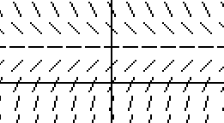
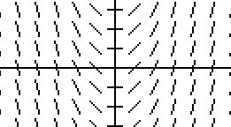
SF1

SF2
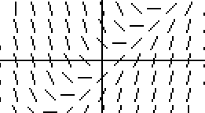
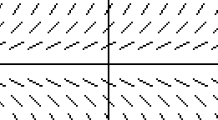
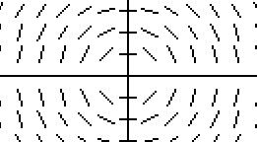
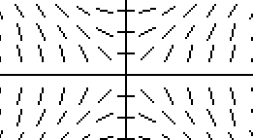
SF3

SF4

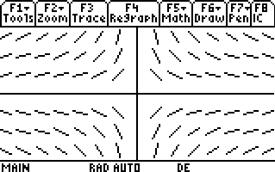
SF5

SF6

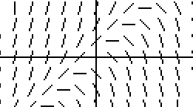
SF7

SF8

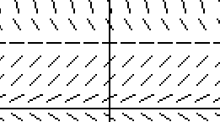
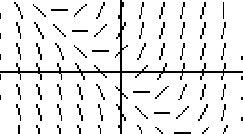
SF9

SF10

DE5

DE9

DE1

DE7

DE4

DE2

DE6

DE3

DE10

DE8

The solution curves
are parabolas.

C10

C8

The solution curve
that passes through
the point is the
line C2

The solution curves
have a horizontal
asymptote only
at y = 0. C6

The solution curves
are circles.

C1

The solution curves
are hyperbolas.

C3

If y > 0 and , the
solution curve is
concave up. If y < 0
and , the solution
curve is concave down.
C9

The solution curve that
passes through the point
(1, 1) has a local
maximum at (1, 1).
C5

The solution curve
that passes through
the point is the
line C4

For y > 0, the solution
curve is logistic and
has two horizontal
asymptotes. C7

SLOPE FIELD CARD MATCH

Slope Fields | Differential Equations | Conclusions
SF 1
SF 2
SF 3
SF 4
SF 5
SF 6
SF 7
SF 8
SF 9
SF 10

SLOPE FIELD CARD MATCH SOLUTIONS
Nancy Stephenson
Clements High School
Fort Bend ISD

Slope Fields | Differential Equations | Conclusions
SF 1 | 5 | 10
SF 2 | 9 | 8
SF 3 | 1 | 2
SF 4 | 7 | 6
SF 5 | 4 | 1
SF 6 | 2 | 3
SF 7 | 6 | 9
SF 8 | 3 | 5
SF 9 | 10 | 4
SF 10 | 8 | 7

